AI ASSISTED CODING

TEST-3

1)CODE:

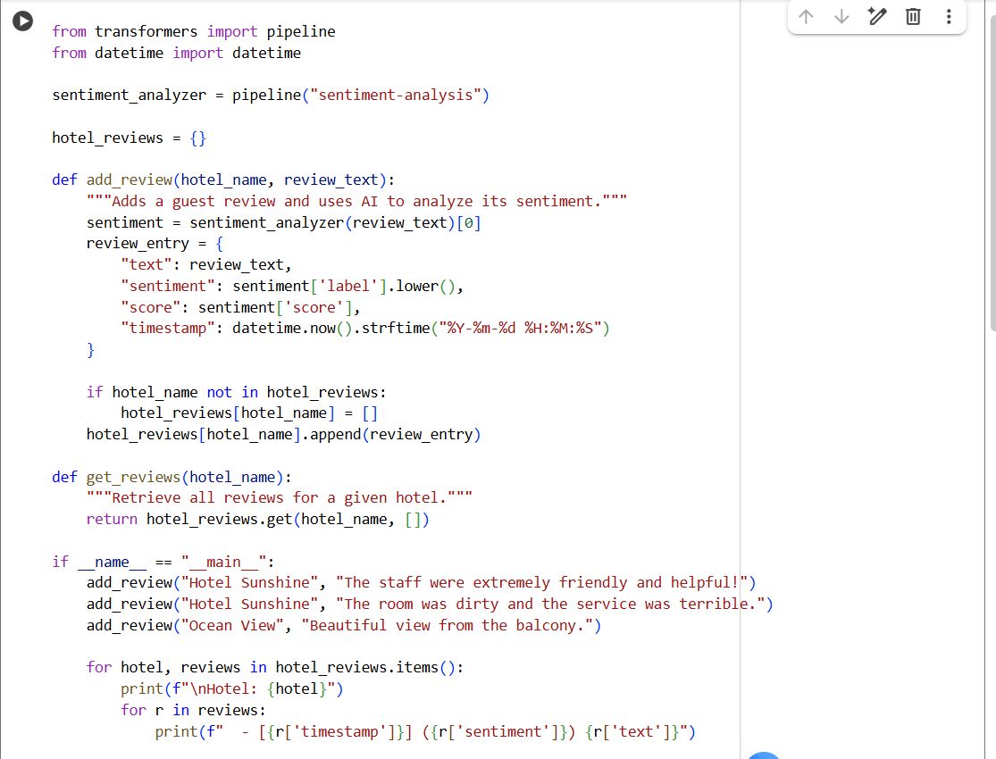

OUTPUT:

EXPLANATION:

2)

CODE:

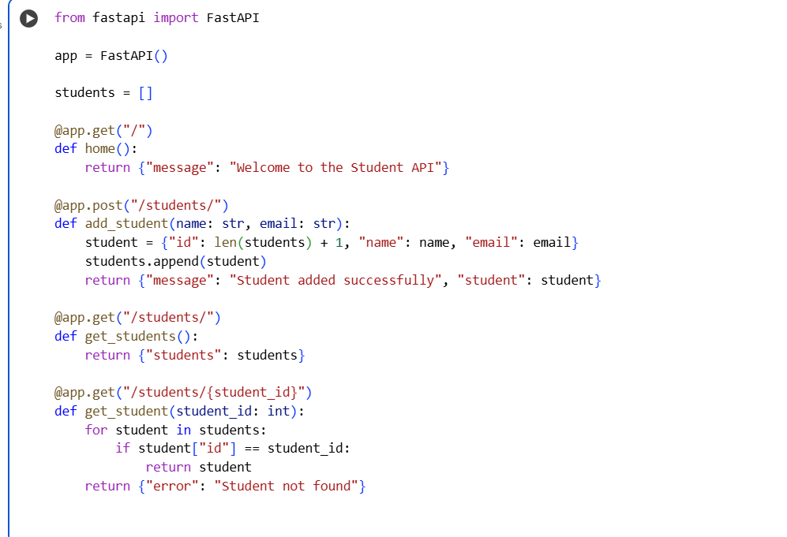

OUTPUT:

EXPLANATION:

